Visits to hospital after transplant

1st month - once a week, every week

2nd month - once a week, every other week

3rd month - once a week, every other week

4th month - once a week, every 4 weeks

Once a week every 4 weeks for 1 more year

Then every 3 months for life

Donor Decisions

* Recent or ex smoker
* Older donor (>60 years)
* Donor with a malignancy that has very low risk of transmission to me
* Bacterial or viral infection considered to be low risk to me
* High risk sexual behaviour or intravenous drug use

Medications after Transplant Surgery

* Cyclosporines
* Tacrolimus
* Mycophenolate Mofetil
* Prednisolone
* Azathuiprine
* Sirolimus
* Dacllizumab and Basilecmab
* OKT3
* Anti-Fungal Medications
* Antiviral Medications
* Diuretics
* Antibiotics
* Anti-ulcer medications

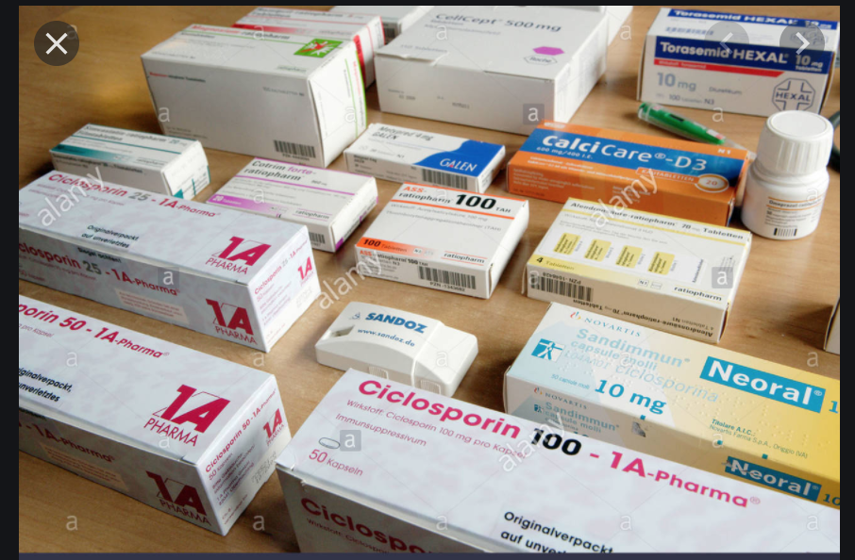

The Window

